
Holy Cross College

Semester 2 Examination 2019
Question/Answer Booklet

Please place your student identification label in this box
Year 10 Earth and Space Science

Student Name
Student’s Teacher

- Time allowed for this paper

Working time for paper: 30 minutes

Materials required/recommended for this paper

- To be provided by the supervisor

This Question/Answer Booklet
Data Sheet

To be provided by the candidate

Standard items: pens, pencils, eraser, correction fluid, ruler, highlighters.
Special items: non-programmable calculators satisfying the conditions set by the School Curriculum and Standards Authority for this course.

Important note to candidates

No other items may be taken into the examination room. It is your responsibility to ensure that you do not have any unauthorised notes or other items of a non-personal nature in the examination room. If you have any unauthorised material with you, hand it to the supervisor before reading any further.

Structure of this paper

Section | Number of questions available | Number of questions to be answered | Suggested working time  (minutes) | Marks available | Percentage of exam
Section One:  Multiple Choice | 10 | 10 | 10 | 10 | 40
Section Two:  Short Answer | 8 | 8 | 20 | 17 | 60
 |  |  |  | 27 | 100

Instructions to candidates

1. The rules for the conduct of examinations at Holy Cross College are detailed in the College Examination Policy. Sitting this examination implies that you agree to abide by these rules.

2. Write your answers in this Question/Answer Booklet.

3. Working or reasoning should be clearly shown when calculating or estimating answers.

4. You must be careful to confine your responses to the specific questions asked and to follow any instructions that are specific to a particular question.

5. Spare pages are included at the end of this booklet. They can be used for planning your
responses and/or as additional space if required to continue an answer.

• Planning: If you use the spare pages for planning, indicate this clearly at the top of the
page.
• Continuing an answer: If you need to use the space to continue an answer, indicate in
the original answer space where the answer is continued, i.e. give the page number.
Fill in the number of the question(s) that you are continuing to answer at the top of the page.

Section I: Multiple choice questions (circle the correct answer)
- Which of the following are correct matches between an Earth system and its main type of contents?
- Hydrosphere – water and ice
- Biosphere – soils and sediments
- Geosphere – oceans
- Atmosphere – air
- The rock cycle operates primarily in which Earth system?
- Atmosphere
- Geosphere
- Hydrosphere
- Biosphere
- Rain falls on a mountainside, seeps into the bedrock and is absorbed by the roots of a pine tree. Apart from the hydrosphere, which Earth systems does the water pass through?
- atmosphere → biosphere → geosphere
- biosphere → geosphere → atmosphere
- atmosphere → geosphere → biosphere
- geosphere → biosphere → atmosphere

- 30% of the Sun's energy that hits the Earth is reflected back into space. The other 70% is:
- partly absorbed by the land and sea surface and partly destroyed by the atmosphere
- absorbed by the land and sea surface only
- absorbed by the atmosphere only
- absorbed by the land, sea and atmosphere
- Which two types of heat transfer do not require the movement of matter?
- Convection
- Evaporation
- Radiation
- Conduction

- Ecosystems involve interactions between which Earth system(s)?
- Biosphere, atmosphere, hydrosphere and geosphere
- Biosphere and atmosphere
- Biosphere only
- Biosphere, atmosphere and hydrosphere

- Which of these statements about greenhouse gases are correct?
- They make up the ozone layer, which protects life from harmful radiation
- They reflect solar radiation back into space
- They make up about 1% of the atmosphere
- They're generally harmful to life on Earth

- Which of the following are greenhouse gases?
- Nitrogen
- Oxygen
- Methane
- Carbon dioxide
- Water vapour

- Which climate zones tend to have high annual rainfall?
- Subtropical
- Temperate
- Polar
- Tropical

- Which of the following are effects of global warming?
- Melting of sea ice, land ice sheets and glaciers
- Crop harvesting occurs earlier in the year than previously
- Sea level rise due to thermal expansion
- Increased use of plastics

Section II: Short answer questions

- Over geological time periods, weathering and erosion can cause an entire mountain range to disappear. Describe how this vast amount of matter is moved around the Earth's surface and how it might eventually become solid rock again. (1 mark)
An entire mountain range can erode away given enough time due to effects of the hydrosphere, atmosphere and biosphere. Rain and snow can react chemically with the rock of the mountain, dissolving some minerals which then flow away in streams to the sea. Temperature changes and movement of water and air, as wind, breaks off tiny particles of rock which also be carried away in streams and some as dust in the wind. Plants sometimes protect the rock, but their roots can also split rock which helps erosion.
The fine particles of rock carried away by streams is generally carried to the ocean where it settles to the bottom as sediment. Sediments build up with new layers on top. As the pressure increases on buried sediments they compress and harden, forming new, sedimentary rock. If there is enough pressure and heat the rock may change to metamorphic rock as well

- What are the Earth’s four major spheres? (2 marks)
Hydrosphere, biosphere, geosphere/lithosphere, atmosphere

- Explain how plants and animals influence the composition of the atmosphere through exchanges of matter. (1 mark)
Plants influence the composition of the atmosphere through the processes of respiration, transpiration and photosynthesis. In respiration they remove oxygen from the air and emit carbon dioxide. In transpiration they put water vapour in the air. In photosynthesis they do the opposite of respiration, removing carbon dioxide and putting oxygen into the air. Overall, plants photosynthesize more than they respire, so they produce more oxygen and absorb more carbon dioxide.

Animals respire but do not photosynthesize, so the remove oxygen from the air and emit carbon dioxide

- Describe a pathway by which carbon moves from the atmosphere through three living things and back into the atmosphere. At each step, explain the process that brings about the carbon transfer. (3 marks)
Example only:
A corn plant photosynthesizes. It takes carbon dioxide from the air and combines it into a glucose molecule. This will later be converted to a starch molecule.
A caterpillar on the corn plant eats a leaf, including the starch molecule. This is the process of feeding. The caterpillar digests the leaf and the carbon atom goes into its body, eventually becoming part of a fat molecule.
The caterpillar is killed by pesticide sprayed onto the corn crop. It falls to the ground and a fungus invades the dead body, decomposing it. The fungus breaks down the fat molecule where the carbon atom is and uses it for respiration in one of its cells. The carbon molecule is bound with two oxygen atoms and returns to the air in a carbon dioxide molecule

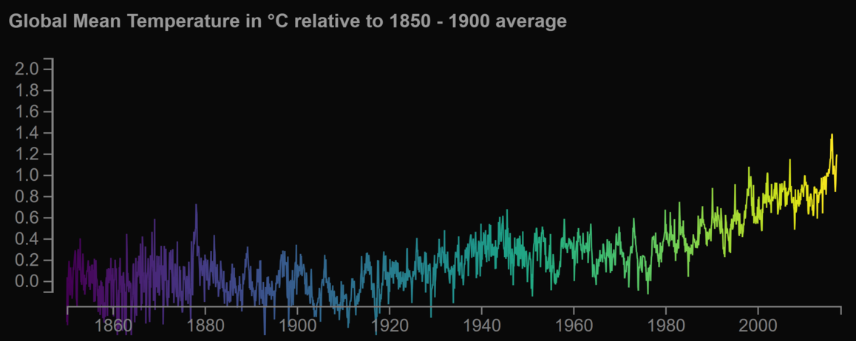
- The above graph shows that global mean temperatures go up and down from one year to the next. For example, 1992 was 0.2°C cooler than the previous year. Use the graph to explain how this is consistent with global warming over the past century. (2 marks)
Variation in the average temperatures from year to year is consistent with an overall trend that can be increasing or decreasing. For example, even though the temperatures in the graph above go up and down from year to year, there is clearly an overall increase in temperature. From 1850 to 1900 the temperatures vary above and below the 0.0 level, while from about 1940 to about 1980 they vary above and below around 0.2. Since the 1990's, all the temperatures have been above 0.4 and some have gone above 1.0. In no year prior to the late 1990's had a temperature been this high
Explain two ways that human activities are impacting the carbon cycle. (2 marks)

Possible effects of human activities on the carbon cycle include:
Burning fossil fuels: This returns carbon to the atmosphere from long-term geological reservoirs, where it has been stored for millions of years.
Deforestation: This destroys trees and plants that remove carbon dioxide from the atmosphere and store it in their tissues.
Cement production: This adds carbon dioxide to the atmosphere by removing it from carbonate rocks, which are a long-term carbon reservoir.
Ocean acidification: Increased concentrations of carbon dioxide in the atmosphere lead to more carbon dioxide being dissolved in the oceans. This causes increased acidity of sea water.
Global greening: Increased concentrations of carbon dioxide in the atmosphere encourage plant growth, at least in areas where they have sufficient water and other nutrients. However, with land clearance this effect is not as great as it might otherwise be
- Give two ways in which humans have contributed to the enhanced greenhouse effect. (2 marks)
Burning Fossil fuels, clearing forests

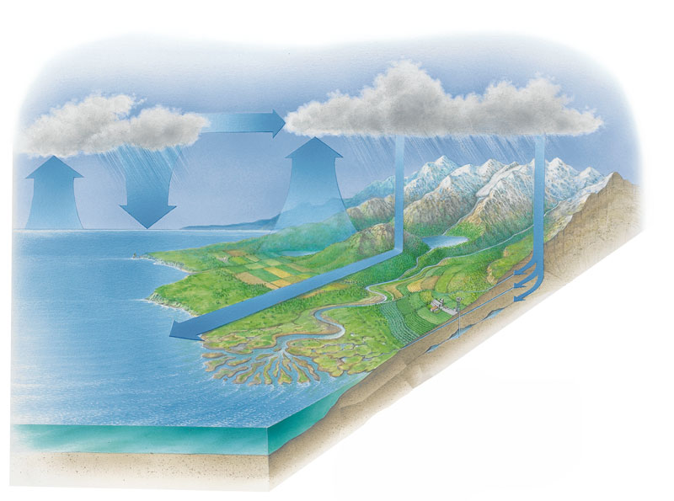
- Using the diagram above, list the main stages of the water cycle. (4 marks)
______________________________________________________________________________________________________________________________________________________________________________________________________________________________________________________________________________________________________________________________________________________________________________________________________________________________

